**PENTAHO Tool Installation**

**STEP 1**: **Download Pentaho**

You can download the files from this link.

The page will look something like this:

You can download the files from this link.

The page will look something like this:

You can download the files from this link.

The page will look something like this:

* Download the files using this link:

(<https://www.hitachivantara.com/en-us/products/lumada-dataops/data-integration-analytics/pentaho-community-edition.html>)

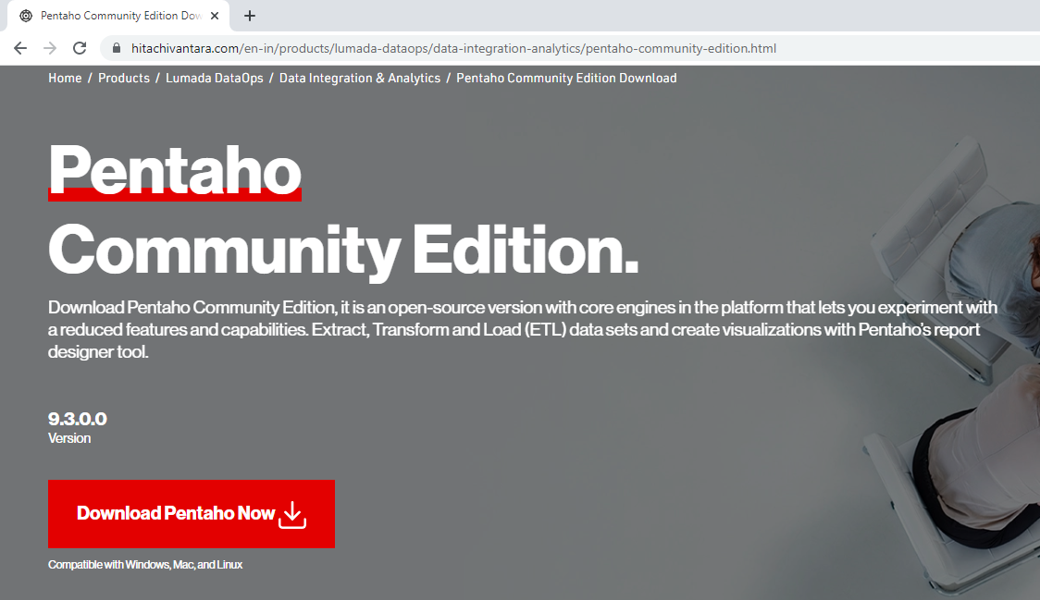

**STEP 2**: **Install the Java Dependencies**

* Download JDK and JRE files from the below links.
* JDK link (https://www.oracle.com/in/java/technologies/downloads/).

JRE link (https://www.java.com/en/download/manual.jsp).

**STEP 3: Set Up the Environment Variables**

* There are three Environment Variables that you need to set up.
* Type in “Environment Variables” in the Windows Search Bar like this

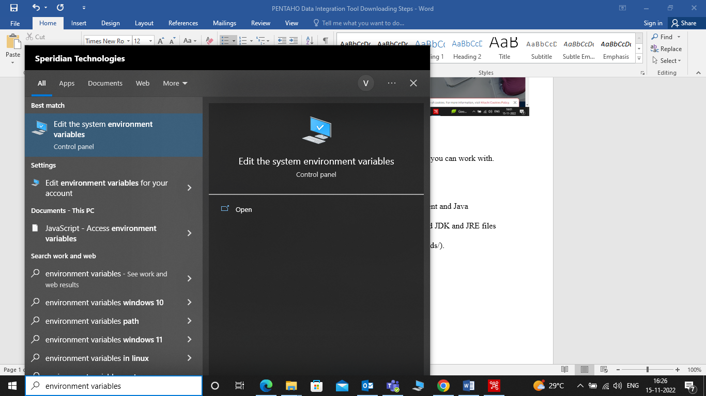

* Click on Edit the system environment variables” option.
* System Properties window will open, Click on “Environment Variables” button at the bottom.

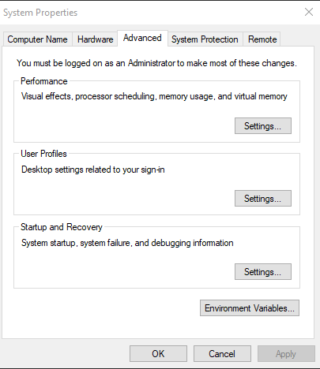

* Popup window will be opened.

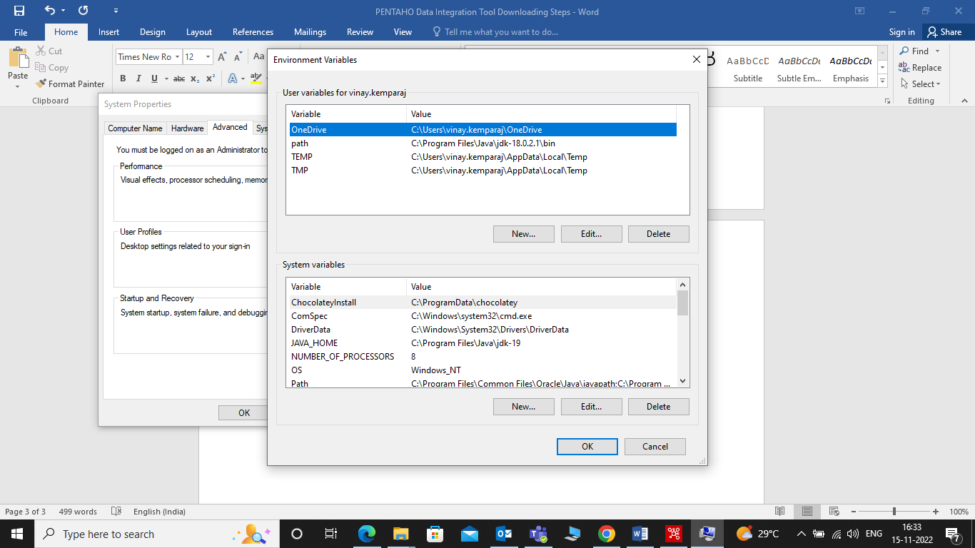

* We need to add three new System variables.
* Click the **New** button under **System variables** and enter the variable name and value

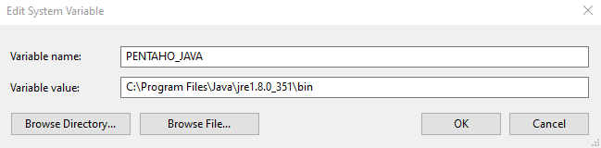

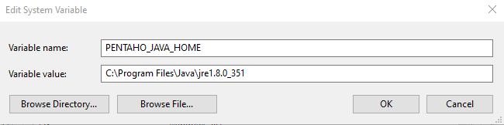

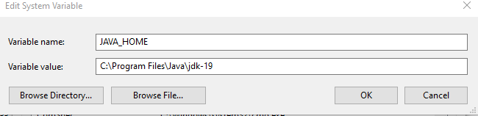

**STEP 4**: **Open the Pentaho File**

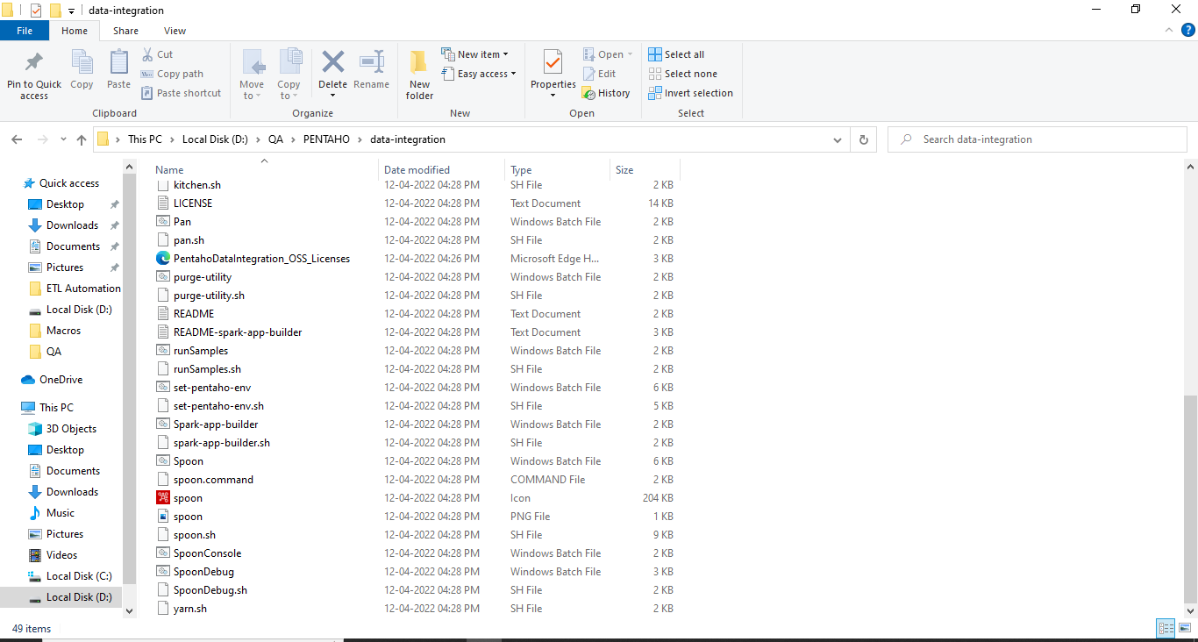

* Double Click on **Spoon**.
* Pentaho Tool will be opened

